IMPLEMENTATION OF A DRUM COLLECTOR FOR ELECTROSPINNING MACHINES BASED ON EMBEDDED SYSTEM

By

Nguyen Thi Hong Phuc

A Thesis submitted to the Biomedical Engineering Department in partial fulfillment of the requirements for the degree of Engineer

Ho Chi Minh City, Vietnam
July-2019

IMPLEMENTATION OF A DRUM COLLECTOR FOR ELECTROSPINNING MACHINES BASED ON EMBEDDED SYSTEM

APPROVED BY: Advisor

________________________________
Do Minh Thai.

ACKNOWLEDGMENTS

I would like to express my heartfelt thanks and gratitude to Ph.D. Nguyen Thi Hiep, Head of Department of Biomedical Engineering. Her constant encouragement and support helped me to achieve my goal.
Furthermore, I would like to express my best profound sense of gratitude to my advisor, Mr. Do Minh Thai for his careful and precious supervision, which were extremely valuable keep me on the correct path since the beginning of my studies.
Besides my advisor, I am greatly thankful to the members of the laboratory A1.408, Mr. Nguyen Phuong Nam and Mr. Tran Ngoc Viet for their technical help and useful critiques both theoretically and practically made this project period become a great learning experience.
My gratitude also goes to all of my friends who directly and indirectly helped me to complete this project, especially my partners, Mr. Nguyen Viet Anh and Mr. Phung Thien Phuc for his patient support and enthusiastic encouragement.
Last but not last least, my sincere thanks to my family and the Biomedical Department for arranging such all facilities to make work more accessible throughout this thesis.

TABLE OF CONTENTS
ACKNOWLEDGMENTS 3
TABLE OF CONTENTS 4
LIST OF FIGURES 6
ABSTRACT 8
CHAPTER 1: INTRODUCTION 9
1.1 Background 9
1.2 Problem statement 10
1.3 Purpose of the project 13
1.4 Organization of Thesis 14
CHAPTER 2: LITERATURE REVIEW 15
CHAPTER 3: MATERIALS AND METHODOLOGY 17
3.1 Mechanical Design 17
3.1.1 Mechanical Material 17
3.2.1 DC Servo Motor (NF5475E with Encoder) 17
3.2.2 Rotating Drum Collector 19
3.3.3 Ground Facility 19
3.3.4 Electrical Control Box 20
3.1.2 Mechanical Design by SOLIDWORKS 20
3.2 Hardware Development 21
3.2.1 Printed Circuit Board Materials 21
3.2.1.1 ARM Cortex-M3 (STM32F103) 21
3.2.1.2 B2412S-1W 24
3.2.1.3 LMD18200T H-Bridge 24
3.2.1.4 TLP280-4 25
3.2.1.5 74HC14D 26
3.1.1 Hardware Design by OrCAD Capture 27
3.1.1.1 Power Supply Block 27
3.1.1.2 Servo Motor Drivers Block 29
3.1.2 Printed Circuit Board Design by Allegro. 31
3.3 Firmware Developing 33
3.3.1 PID Algorithm 33
3.3.2 Methodology 36
3.4 Operation Instruction 38
CHAPTER 4: RESULTS 40
4.1 Optimized Parameters 40
4.2 Morphology Analysis 41
4.2.1 Membrane fabricated by the implemented Rotating Drum Collector for Electrospinning 41
4.2.2 Membranes under SEM image observation 41
CHAPTER 5: DISCUSSION AND IMPLEMENTATIONS 42
5.1 Economic Assessment 42
5.1.1 Value proposition 42
5.1.2 Existing commercial products 42
5.2 Benefits and room for future improvement 43
CHAPTER 6: CONCLUSION 45
REFERENCES 46

LIST OF FIGURES
Figures Page
LIST OF FIGURES
Figure 1: Electrospinning system for nanofibers production. 10
Figure 2: The Spraybase® Rotating Drum collector. 11
Figure 3: Some kinds of Collectors. 12
Figure 4: Rotating continual collector. 13
Figure 5: Nanospinner PilotLine Semi Industrial Electrospinning Machine 16
Figure 6: Servo DC NF5475E 18
Figure 7: Motor Specification [1] 18
Figure 8: The aluminum rotating drum collector 19
Figure 9: Components of the Collector System. 21
Figure 10: STM32F103xC, STM32F103xD and STM32F103xE features and peripheral 23
Figure 11: The STM32f103xC performance line block diagram 24
Figure 12: Internal Structure of Optocoupler 25
Figure 13: Schmitt trigger 26
Figure 14: Layers of PCB 31
Figure 15: Top layer of PCB 32
Figure 16: Bottom Layer of PCB 33
Figure 17: The state machine diagram of Drum Control System 38
Figure 18: The grounded connection system 41
Figure 19: Design of the Drum Collector 41
Figure 20: MSK-ESDC-80-Series 42
Figure 21: Gantt Chart for Thesis 44

ABSTRACT
Nowadays, there has been an enormous rise in the request for polymeric nanofibers which are promising candidates for numerous applications including tissue engineering, blood vessels, nervous system, drug delivery, protective clothing, filtration, and sensors. Some of the techniques have been developed to address this demand, and the electrospinning technique is adequately referenced for its effectiveness in the production of nanofibers.
The electrospinning device is used in the biomaterials research field for fabricating nanofibers that can be used for manufacturing artificial skin and muscular tissue, blood vessels (vascular grafts), orthopedic components (bones, cartilages, and ligaments/tendon), and peripheral or central nervous system components. Electrospun nanofibers act as ideal scaffolds for tissue engineering, regenerative medicine, and drug delivery systems because they can mimic the functions of native extracellular matrices.
This research aims to implement a low-cost electrospinning device which was designed and built for practical learning in the Regenerative course in the area of Biomedical Engineering at International University, Vietnam. The prototype is a user-friendly and cost-effective platform; its cost is much less than the commercial laboratory devices.

CHAPTER 1: INTRODUCTION

  - Background
Submicron-sized fibers have played an essential role in produce fiber from submicron to nanoscale regarding applications, including those in protective clothing, pharmaceutical, tissue engineering, and regenerative medicine.
A polymer solution is pumped by a syringe pump through a small needle to form a small pendant droplet at the needle tip. The needle is charged to a high voltage, typically about 20kV, a Taylor cone is formed at the tip of the nozzle. A fine
jet ejects from the tip of Taylor cone when the electric field overcomes the surface tension. The charged jet then has an intensive interaction with the electric field formed between the nozzle and the collector, making it undergo a whipping movement. Solvent evaporation from the jet leads to solidification of the solution jet turning into fibers, which deposit onto the collector in the form of randomly-oriented fibrous mats in most of the case. [2]
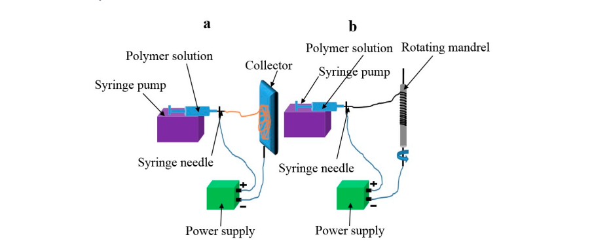
Figure 1: Electrospinning system for nanofibers production.

  - Problem statement
Nanofiber plays an integral role in various application in which are widely used in tissue engineering for scaffold making, wound healing, implant materials, drug delivery or medicinal materials. The primary electrospinning system consists of an injection pump, syringe, high voltage power, and a collector plate.
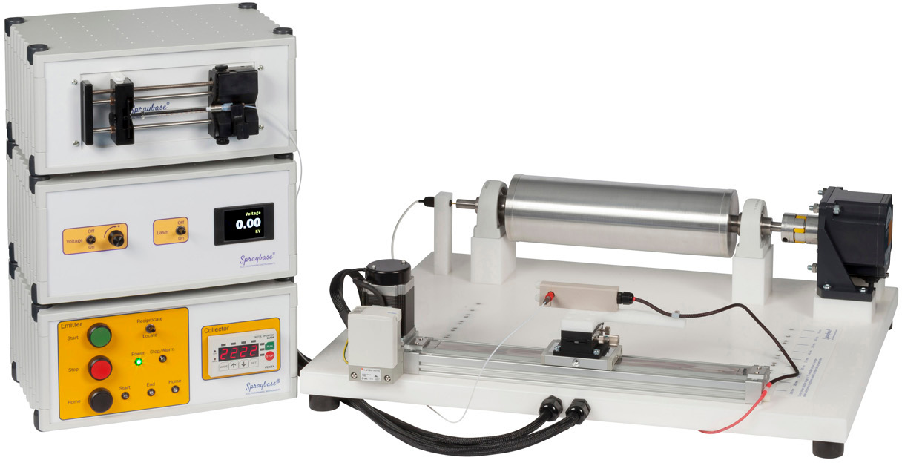
Figure 2: The Spraybase® Rotating Drum collector.
This electrospinning research investigated the polymeric nanofiber production in the aspect of the implementation of a rotary drum collector for electrospinning machines based on an embedded system.
The flying nano-sized fiber, once stiff, settle on their surface. Fibers are gradually deposited as layers on the collectors to create nanofiber material.
The collector design is always adapted to the product requirements in terms of the size and internal morphology of the nanomaterial. [3]
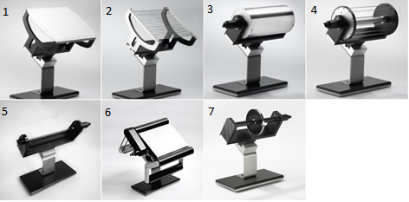
Figure 3: Some kinds of Collectors.
- Static continual collector
- Static patterned collector
- Rotating continual collector
- Rotating patterned collector for electrospinning
- Tube collector
- Endless Belt
- Rotating thin disc

In this study, the continual rotating collector is implemented to obtain aligned polymeric fibers in usage for regenerative engineering such as scaffold making, wound healing, implant material that profoundly adapted to the researches of Biomedical Engineering Department in International University.
The rotating collector (as figure 3 below) is in the standard shape of a drum, the surface of which comprises an electrically continual surface. At slow speeds, the fibers are randomly deposited on the drum surface. This generates a larger sample of the material than the static collector. If the collector is controlled at higher speeds, fibers are deposited on the surface in the preferred direction. This enables larger-dimensioned materials to be obtained, the internal structure of which is, on average,well-aligned. | 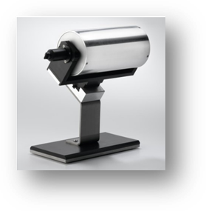  Figure 4: Rotating continual collector.

  - Purpose of the project
The basic electrospinning offers researchers a low-cost, versatile and portable electrospinning setup consisting of 3 main components required for electrospinning: an emitter connected to a high-voltage power supply, a collector, which is either earthed or connected to a negative high-voltage power supply, and a solution feeding system such as a syringe pump.
Using this system, various polymers and composite materials have the potential to be electrospun, and the process is easy and economical.
In this investigation, the rotating drum collector has been accomplished on the embedded platform as a very first step of building a whole system of rotating drum collector for electrospinning. To illustrate this, this research aims to implement the Rotary Electrospinning System- one of the main components of Electrospinning system - which has been driving by LMD18200T, a 3A H-Bridge - processed by STM32F103xx, medium-density performance ARM®Cortex®-M3 32-bit RISC core, high-speed embedded MCU in terms of nanofiber production besides providing the user-friendly and cost-effective platform.

  - Organization of Thesis
The remaining of this thesis is divided into the following sections:
Chapter 2: Literature Review will show techniques researcher has been used in literature. Chapter 3: Methodology will show the materials and methods we implement to handle the problem.
Chapter 4: Result will show our result that has a positive impact on the experiment’s quality.
Chapter 5: Conclusion will show a summary of the study and some further development ideas.

CHAPTER 2: LITERATURE REVIEW
Since the first emergence in 1934, electrospinning has contributed a versatile method in the fabrication of many types of scaffolds used in different fields of biomedical engineering, tissue engineering, and regenerative medicine.
Before that, the platform used for wound healing was mainly fabricated by simple methods, including drawing techniques, spinneret-based tunable engineered parameter (STEP) method, phase separation, self-assembly, template synthesis, freeze-drying synthesis, and interfacial polymerization of nanofibers. [1] Although their working principles are quite simple and do not require high technologies, characteristics of scaffolds created by these methods are difficult to control. To tackle this problem, electrospinning is an advanced technique which is especially suitable for the fabrication of many types of polymeric materials, including natural and synthetic polymers.
This technique shares characteristics of both electrospraying and conventional solution dry spinning of fibers, the process does not require the use of coagulation chemistry or high temperatures but can produce solid threads from solution directly. The past two decades have witnessed the blossom of the traditional electrospinning technique, and many derivative methods have been emerged such as multi-jet electrospinning, needleless electrospinning, bubble electrospinning, electro-blowing, cylindrical porous hollow tube electrospinning, melt electrospinning, coaxial electrospinning, force spinning, flash-spinning, self-bundling electrospinning, nano spider electrospinning, charge injection electrospinning, etc. [1]
The simplest and earliest form of electrospinning involves the use of a single-needle spinneret to draw the solution out and form fibers. The process, however, is very time consuming, limiting the potential wide-scale application of electrospun nanofibers. Many multiple-jet electrospinning methods have been proposed to overcome the problem of low productivity, but the generation of multiple jets brought about other issues such as jet repulsion, lower process controllability, and deterioration of fiber quality. [1]
We found that some innovative electrospinning machine design. Take PilotLine Industrial Electrospinning Machine into consideration; using Bottom-Up spinning, the rotary drum is hang up on the top of the cabinet while up to 55 concurrently feeding nozzles were spraying from the bottom. The model is specifically suited to engage in electrospinning over long time intervals requiring in-situ parameter optimization. | 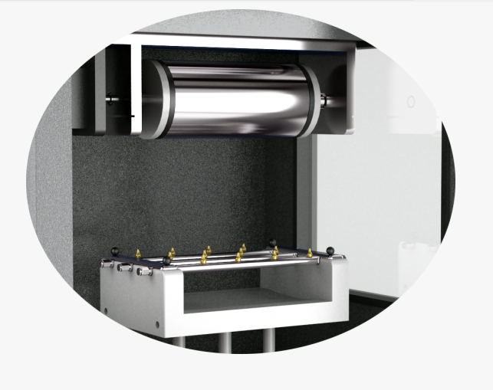  Figure 5: Nanospinner PilotLine Semi Industrial Electrospinning Machine

CHAPTER 3: MATERIALS AND METHODOLOGY
  - Mechanical Design
    - Mechanical Material

3.2.1 DC Servo Motor (NF5475E with Encoder)
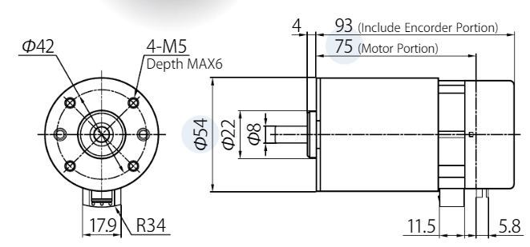
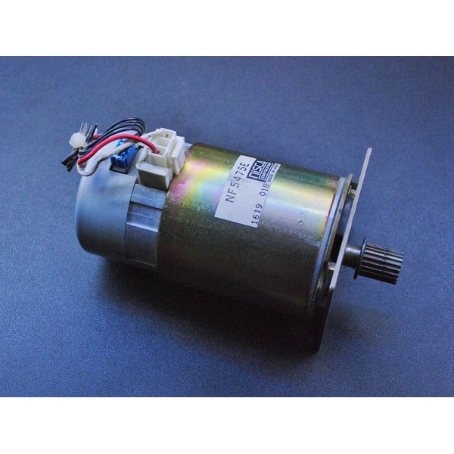  Figure 6: Servo DC NF5475E | Technical Specification:  (At maximum Efficiency)  Input Voltage: 24 (V)  Speed: 3000 (rpm)  Current: 1.256 (A)  Encoder Resolution: 200 (P/R)

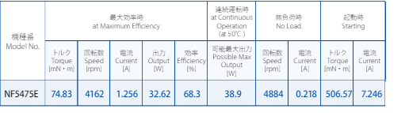
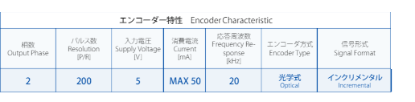
Figure 7: Motor Specification [1]

3.2.2 Rotating Drum Collector
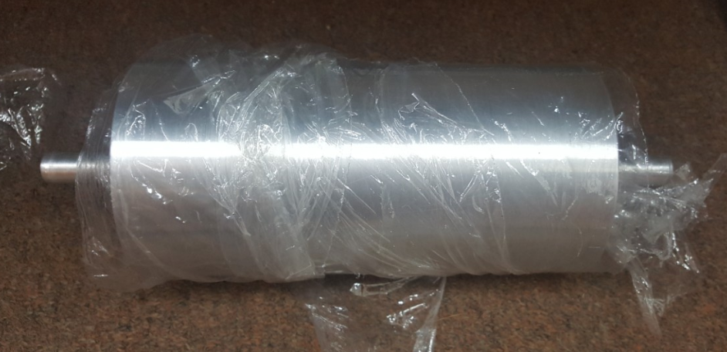
Figure 8: The aluminum rotating drum collector

Collector Design: Collector plate
The external diameter of the drum | 100 mm
The internal diameter of the drum | 15 mm
The length of the drum | 200 mm
The length of the shaft | 45 mm.

Table 1: Collector Plate Parameters

3.3.3 Ground Facility
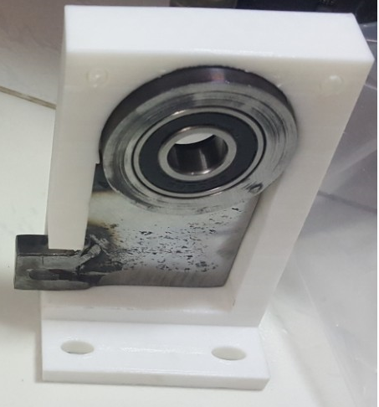  Figure 9: Negative electrical conductivity Component | The collector plate will be good at negative electrical charge conductivity via crocodile clip which is attached to the designable metal holder as the illustrated figure below.

3.3.4 Electrical Control Box

    - Mechanical Design by SOLIDWORKS
The fundamental rotating drum collector for electrospinning consists of 4 main parts:
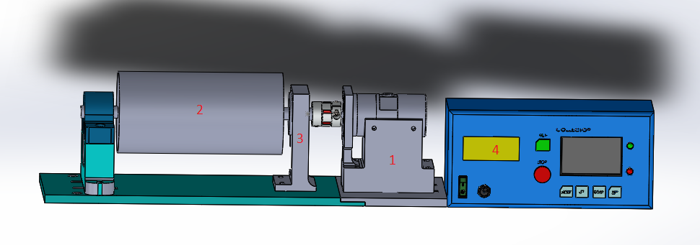
Figure 10: Components of the Collector System.
1. Motor Control System 2. Rotary Drum Collector
3. Ground-Connected System 4. Electrical Control Box

  - Hardware Development
    - Printed Circuit Board Materials
      - ARM Cortex-M3 (STM32F103)
The STM32F103xC performance line family incorporates the high-performance ARM® Cortex™-M3 32-bit RISC core operating at a 72 MHz frequency, high-speed embedded memories (Flash memory up to 512 Kbytes and SRAM up to 64 Kbytes), and an extensive range of enhanced I/Os and peripherals connected to two APB buses.
The features of STM32F103:
- Code-efficiency, lower consumption, high performance
- Memories
- 256 to 512 Kbytes of Flash memory up to 64 Kbytes of SRAM
- Debug Mode:
  - Serial Wire Debug (SWD) & JTAG interfaces
- Clock, reset and supply management
  - 2.0 to 3.6 application supply and I/Os
  - 4-to-6 MHz crystal oscillator
- Peripherals
  - Three 12-bit ADC
  - Four general-purpose
  - 16-bit timers + two PWM timers
  - Two I2Cs
  - Three SPIs
  - One SDIO
  - Five USARTs
  - A USB and a CAN
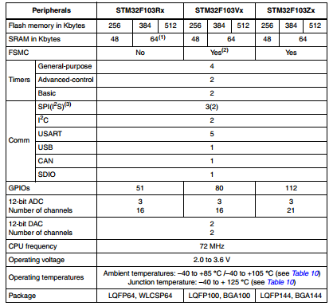
Figure 11: STM32F103xC, STM32F103xD and STM32F103xE features and peripheral
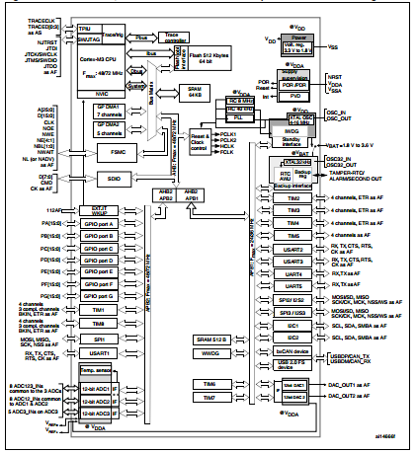
Figure 12: The STM32f103xC performance line block diagram
      - B2412S-1W
Isolated DC-DC converters convert a source of direct current (DC) from one voltage to another and contain an electrical barrier between the input and output to improve safety.
      - LMD18200T H-Bridge
The LMD18200 is a 3A H-Bridge designed for motion control applications. The device is built using a multi-technology process which combines bipolar and CMOS control circuitry with DMOS power devices on the same monolithic structure. Ideal for driving DC and stepper motors; the LMD18200 accommodates peak output currents up to 3A. An innovative circuit which facilitates low-loss sensing of the output current has been implemented. In this project, LMD18200 which is used for control motor to control collector which spin suitable for the application.
      - TLP280-4
Opto-coupler is an electronic component that transfers electrical signals between two isolated circuits, especially low voltage or highly noise-sensitive circuits. To this end, the optocoupler is used to isolate circuitry to prevent electrical collision chances or to exclude unwanted noises.
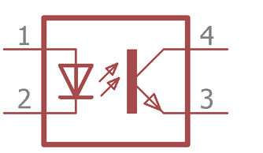
Figure 13: Internal Structure of Optocoupler
Space is transparent and non-conductive material; it is electrically isolating two different circuits. The LED on the left side emits infrared light to the photosensitive transistor on the right side. The photo-transistor switches the output circuitry by its collector and emitter, same as typical BJT transistors. The intensity of the LED directly controls the photo-transistor. [1]

      - 74HC14D
The 74HC14D is a high-speed CMOS SCHMITT INVERTER fabricated with silicon gate C 2MOS technology. With its Schmitt trigger function, the 74HC14D can be used as a line receiver which will receive slow input signals.
Schmitt trigger is a comparator circuit with hysteresis implemented by applying positive feedback to the noninverting input of a comparator or differential amplifier. It is an active circuit which converts an analog input signal to a digital output signal. The output retains its value until the input changes sufficiently to trigger a change.
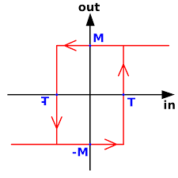
Figure 14: Schmitt trigger

Schmitt trigger devices are typically used in signal conditioning applications to remove noise from signals used in digital circuits, particularly mechanical contact bounce in switches.

    - Hardware Design by OrCAD Capture
      - Power Supply Block
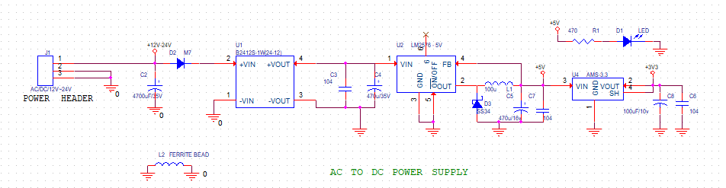
The system requires +3.3v, +5v, and +24v DC power, the main power supply is taken from DC adapter +24v need to convert to lower voltage to perform the microprocessors and the rest components on board. To this end, the isolated DC-DC B2412S-1W is taken into consideration to convert from +24v to +12v and overcome the electromagnetic noise of the high voltage power lines. They then turn to +5V and +3.3v by LM2576-5v and AMS1117-3.3v regulator executing respectively.
The design of control systems of DC servo motor based on the embedded microprocessor STM32F10x and the embedded integrated develop environment MDK. In comparing to the Arduino platform, ARM has been much more superior capabilities, faster processor speeds, number of peripherals like ADC and GPIOs, USB, etc.
By executing powerful features, ARM Cortex-M3 chip achieves throughputs approaching a higher speed which guarantees me a more effective response in a motor control system allowing the system designer to optimize power consumption versus processing speed.
The two timers TIM1-CH4 and TIM2-CH3 are used for PWM generating.
Encoder mode is active by timer encoder TIM3 and TIM8 respectively.
The ARM chip – Cortex-M3 by STMicroelectronics allows the use of more complex algorithms, clear the scalability of processors and adopt a more robust microcontroller in case of more resources without troubling about rewriting the code to a new architecture.
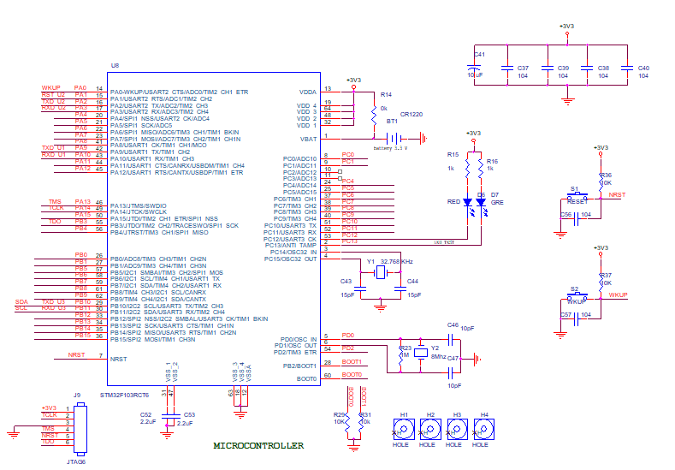
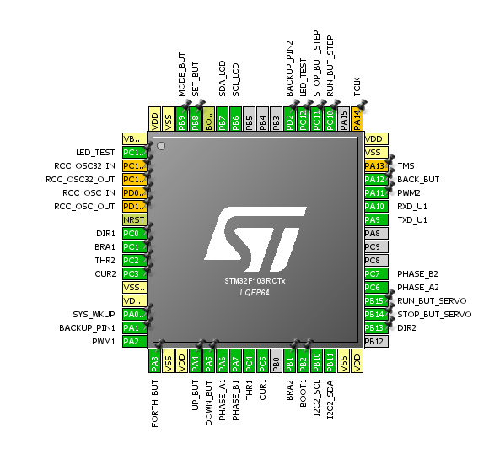
      - Servo Motor Drivers Block
The motor control system uses an encoder DC servo motor running the rotating drum collector. The servo motor has a rotation detector (encoder) mounted on the back-side shaft of the engine to detect the position and the speed of the rotor. As a result, it reaches the rotating drum collector's specifications in terms of high-speed operation with high accuracy.
Compare to the stepper motor, the servo motor is more suitable for high speed, high torque application that plays a very important for aligned fiber production.
The LMD18200T chip provides the intuitive visual in pin configuration. A most basic way would be to utilize only three pins: DIR, PWM, and BREAK; they then become more accessible to program the firmware for operating. Hence, the codes for controlling the motor driver will be simplified and easy to debug.
Optical isolator TLP280-4 is being to isolate two separated low voltage (+5v and +3v3) and high voltage in order to remove electrical unwanted noise and collision as well. Due to the unstable mechanism, 74HC14D is typically used in signal conditional to prevent encoder reading value from missing or incorrect pulse.
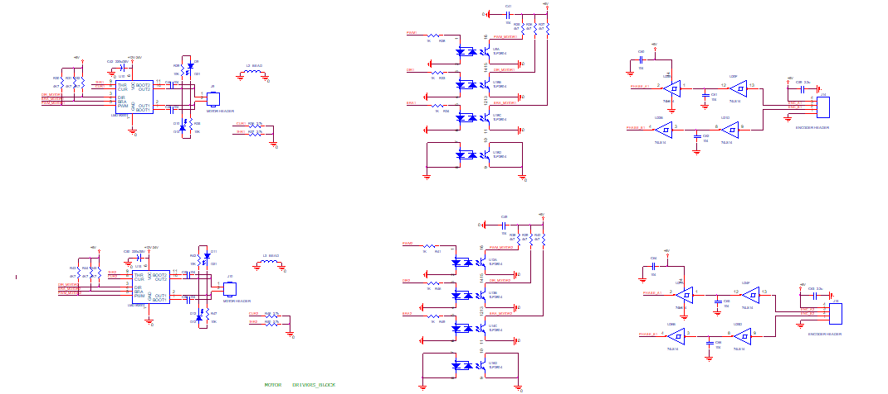
    - Printed Circuit Board Design by Allegro.
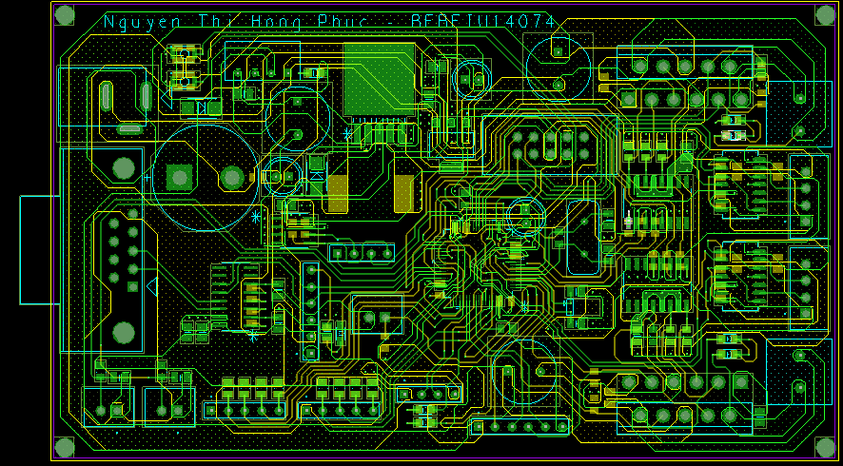
Figure 15: Layers of PCB
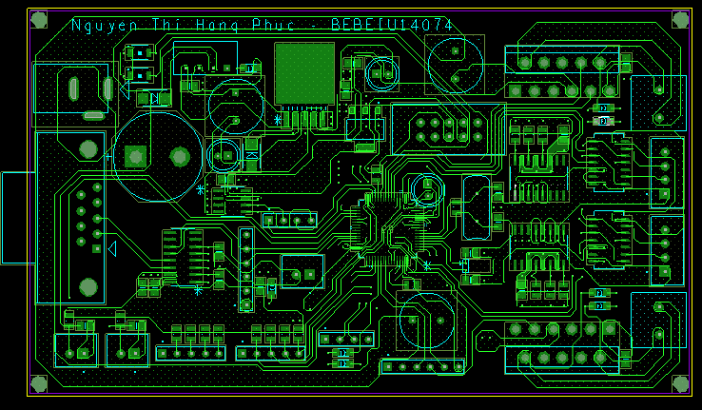
Figure 16: Top layer of PCB
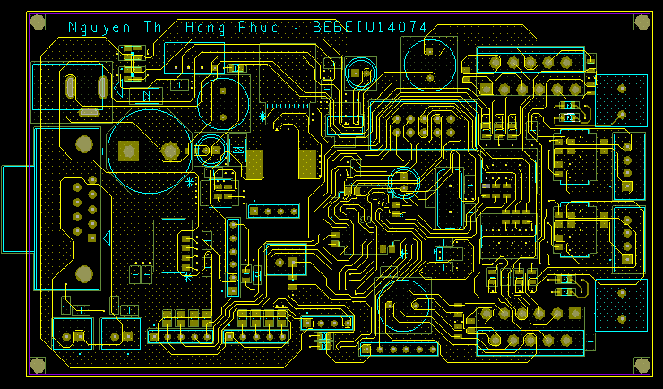
Figure 17: Bottom Layer of PCB
  - Firmware Developing
    - PID Algorithm
PID controller maintains the output such that there is zero error between the process variable and setpoint/ desired output by closed-loop operations. PID uses three basic control behaviors that are explained below.
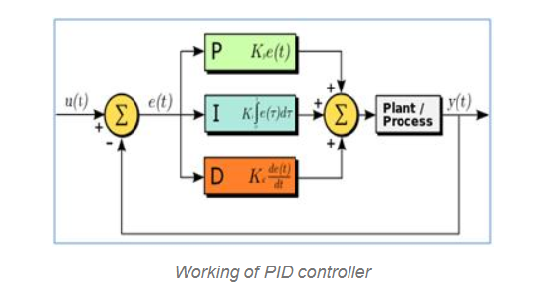
P-controller

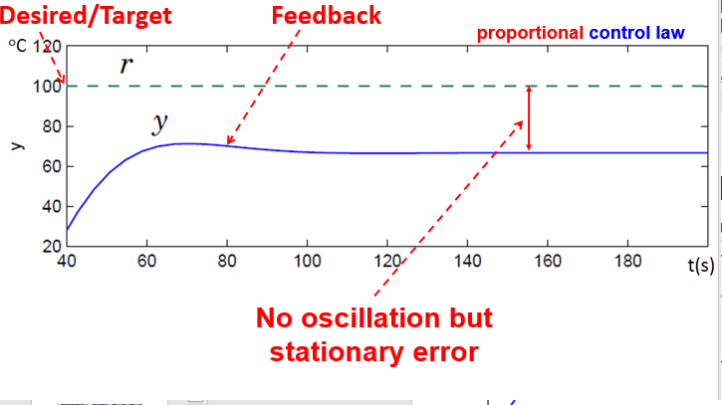
Proportional or P- controller gives an output which is proportional to current error e (t). It compares the desired or set point with actual value or feedback process value. The resulting error is multiplied with a proportional constant to get the output. If the error value is zero, then this controller output is zero. It provides stable operation but always maintains the steady-state error. Speed of the response is increased when the proportional constant Kc increases.
I-controller
Due to the limitation of p-controller where there always exists an offset between the process variable and setpoint, I-controller is needed, which provides necessary action to eliminate the steady-state error. It integrates the error over a period of time until the error value reaches zero. It holds the value to the final control device at which error becomes zero.
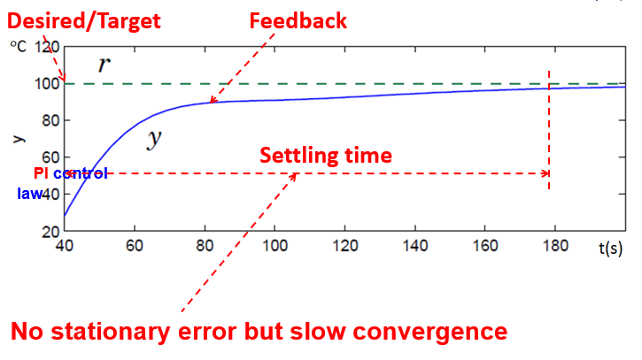
Integral control decreases its output when a negative error takes place. It limits the speed of response and affects the stability of the system. Speed of the response is increased by decreasing integral gain, Ki.

D-controller
I-controller doesn’t have the capability to predict the future behavior of error. So it reacts normally once the setpoint is changed. D-controller overcomes this problem by anticipating the future behavior of the error. Its output depends on the rate of change of error with respect to time, multiplied by derivative constant. It gives the kick start for the output thereby increasing system response.
In the above figure response of D part, the controller is more, compared to the PI controller and also settling time of output is decreased. It improves the stability of the system by compensating phase lag caused by I-controller. Increasing the derivative gain increases the speed of response.
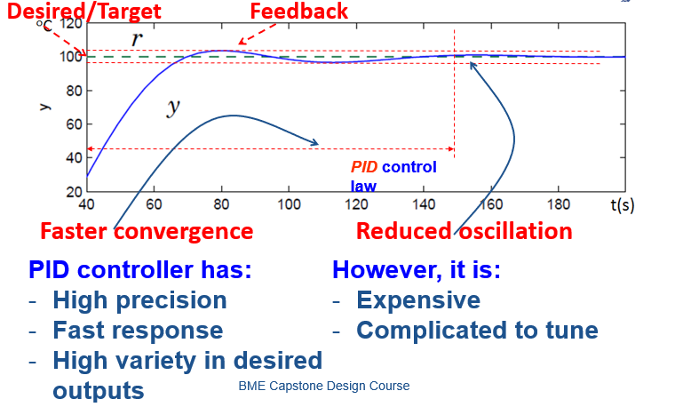
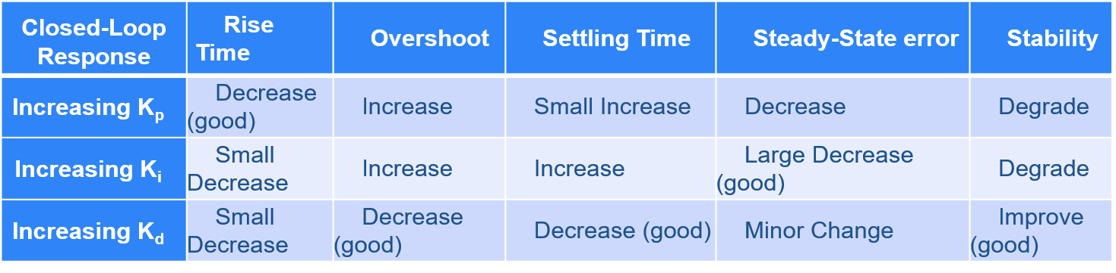
    - Methodology
The embedded system processes the speed value (unit: rpm) accessed from signal control entering from buttons.
An optocoupler then continues to be treating these driving signals, intending to eliminate undesired electrical collision. Following the pulse intake of the LMD18200 driver, it would control the DC servo motor through following accessible programming features: PWM, DIR, BRAKE.
Due to the vibration of the mechanical system, it is more prone to unwanted noises; the Schmitt trigger 74HC14D tackle that problem efficiently.
Take the encoder of 200 pulses per revolution, so the formula has been implementing to estimate values of the real speed illustrated as:
actualSpeed=(encoderPulse*6000)/200;
In which "encoder pulse" - the value is reading from timer every ten milliseconds.
Most notably, the PID and Moving Average algorithm applied to enhance the accuracy and optimized automatic control.
What is more, aiming the increase of the accessibility of the following manipulation, the EEPROM was enhanced. While accessing this mode, the motor speed update automatically and drive the system.
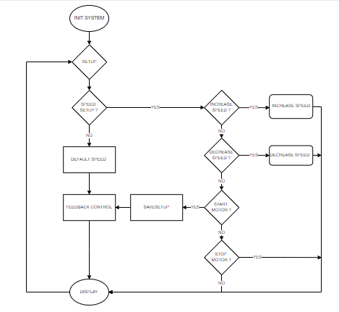
Figure 18: The state machine diagram of Drum Control System

  - Operation Instruction
Our system was designed with the intention of the most straightforward usage for consumers.
Being affected by a high voltage power, it should take into careful accounts for physicians to performance during usage to remain its functions and safety. Rigorous compliance with the following instructions is also highly recommended:
1 Set up the syringe pump
2. Set up the slider parameters
3. Set up and turn on the Drum Collector system
Notes: It is necessary to wait for a short time to the drum system reaches its sustainability.
4. Turn on the switch from the Slider system
6. Set up the high voltage power and turn on
Note: This is the very last step for the system performance as electrical safety reasons.

CHAPTER 4: RESULTS
  - Optimized Parameters
The DC servo motor is used to control the rotating drum collector with accurate high speed in terms of nanofibers production.
Optimization of the various processing parameters for electrospinning was also done, the results of which were listed below.
Table 2: Results of parameters electrospinning setup
Process parameter | Optimized values
Type of solvent used | (ratio)
Polymer solution concentration
Flow rate
Applied voltage
Tip to collector distance
Diameter of needle
Speed of Collector plate

Figure 19: The grounded connection system | Figure 20: Design of the Drum Collector
  - Morphology Analysis
Using the above processing parameters, electrospinning was done and the fibers were obtained on the rotating drum collector setups.
    - Membrane fabricated by the implemented Rotating Drum Collector for Electrospinning
    - Membranes under SEM image observation

CHAPTER 5: DISCUSSION AND IMPLEMENTATIONS

Economic Assessment

Value proposition
Our goal project is to become an easy-to-use device for technicians for polymeric nanofiber production. Desired parameters as speed control, encoder reading for P.I.D control plays an essential part in helping physicians to manipulate.

Existing commercial products
There have been researches conducted; however, we have not found any specific products similar not only the Electrospinning machine but can even Drum Collector System in Viet Nam market. One of the most prominent suppliers such as Spraybase whose Drum Collector has costs varying from $2,000 to $10,000, for globally.
The most similar product noticed is model MSK-ESDC-80-450 by MTI Corporation (USA) which gives out similar parameters costs about 69,913,780 (VND) compare to our collector system supposed to be around 3,000,000 (VND).
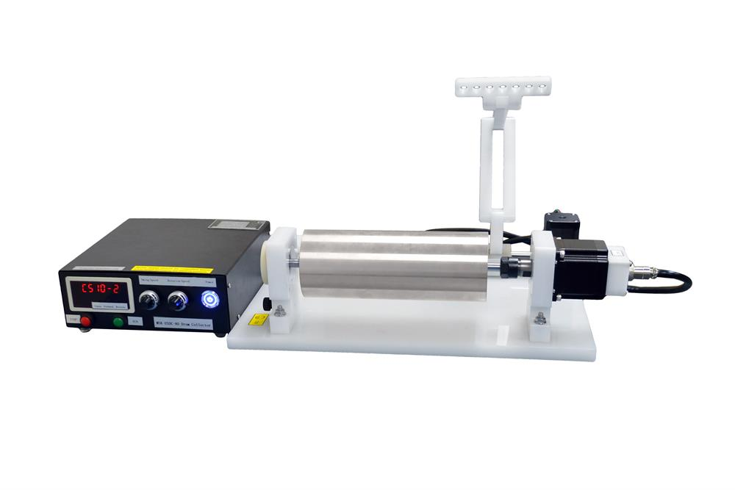
Figure 21: MSK-ESDC-80-Series

Benefits and room for future improvement
This protocol has been reliably proving that a collection module design is a tempting approach to facilitate electrospinning activity. The control panel is straightforward and extremely user-friendly, allowing us to adjust the parameters easily. What is more, the system will automatically regulate the motor speed when the desired speed is unequal the actual speed.
The evaluation on developing the prototype for Rotating Drum Collector has started in the middle of February 2019 and ended on June 2019, hence the total time of development approximately four months.

Task | Starting Week | Weeks to Complete
Find mechanical material | 25 | 2
Set-up mechanism | 27 | 2
Design Circuit Layout | 29 | 2
Making PCB | 31 | 1
Build an electrical circuit | 32 | 1
Test Circuit | 33 | 1
Debug firmware | 31 | 4
Set up experiment | 35 | 2
First Prototype | 36 | 1
Report + Presentation | 35 | 6
Last prototype | 38 | 2
Backup weeks | 40 | 4

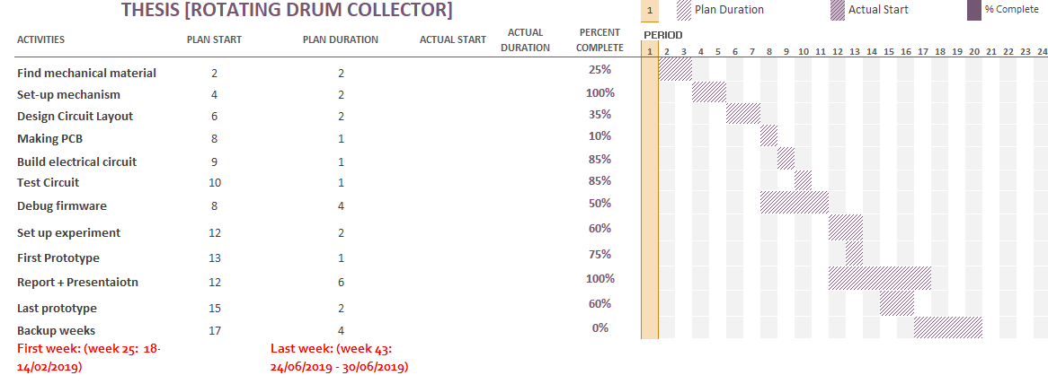
Figure 22: Gantt Chart for Thesis

CHAPTER 6: CONCLUSION

In conclusion, the experiment has brought a promising approach to support one option of the collection module of electrospinning machine- Rotating Drum Collector. This particular design of Rotating Drum Collector is generally efficient to revolve in 2000 rpm in practical with a closed-loop system in aspect to obtain aligned polymeric fibers with a user-friendly interface and affordable cost.

REFERENCES

[1] | A. Adhi, B. Philip, and R. Andrew, "The Effect of Rotating Collector Design on Tensile Properties and Morphology of Electrospun Polycaprolactone Fibres," EDP Sciences, Australia, 2015.
[2] | G. G. Chase, J. Sunthorn Varabhas and . D. H Reneker, "New Methods to Electrospun Nanofibers," Akron, 2011.
[3] | 4SPIN, "Types of collectors and aligned nanofibers - 4SPIN," [Online]. Available: https://www.4spin.info/portfolio/collectors.
[4] | STMicroelectronics, STM32F103xC STM32F103xD STM32F103xE Datasheet, STMicroelectronics.
[5] | S. Gupta, "CircuitDigest," 7 5 2018. [Online]. Available: https://circuitdigest.com/tutorial/opto-coupler-types-working-applications. [Accessed 19 5 2019].
[6] | Electronics|Project|Focus, "Electronics|Project|Focus," [Online]. Available: https://www.elprocus.com/the-working-of-a-pid-controller/. [Accessed 19 5 2019].
[7] | "DOKUMEN," NISCA, [Online]. Available: https://dokumen.tips/documents/nisca-dc-motor-1.html. [Accessed 10 7 2019].
[8] | I. A. a. S. Alomari, "Different Methods for Nanofiber Design," Springer International Publishing, Damascus, 2018.
[9] | E. N. M. W. N. L. M. Hanna Sofia Salehhudin, "Multiple-jet electrospinning methods for nanofiber processing: A review," Kuala Lumpur, 2017.

